**Recursion**

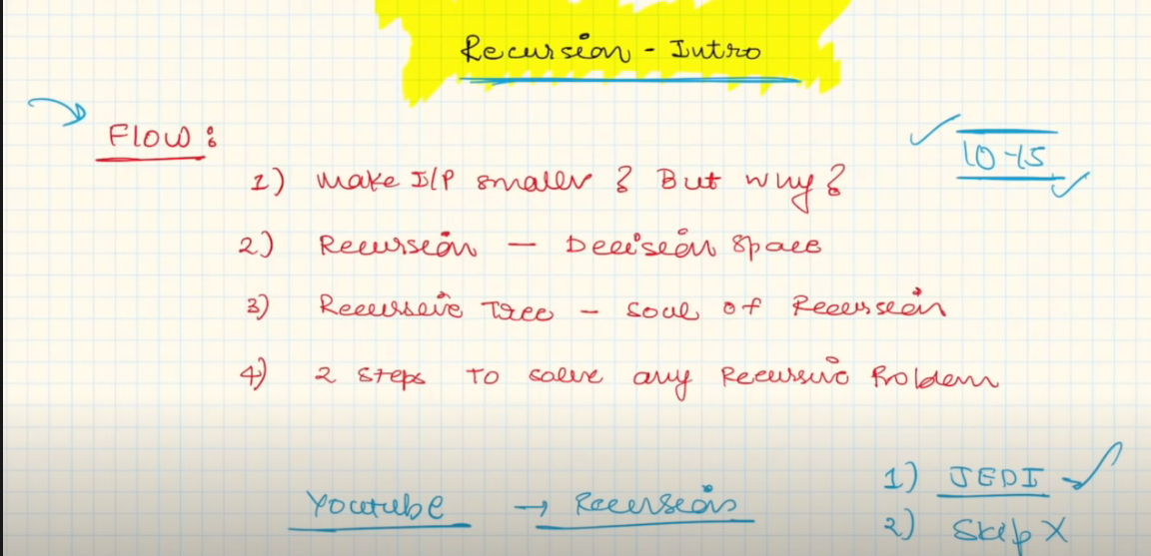

1. In recursion we don’t try to make the input smaller but we make a sequence of decisions and because of that input size is reduced.

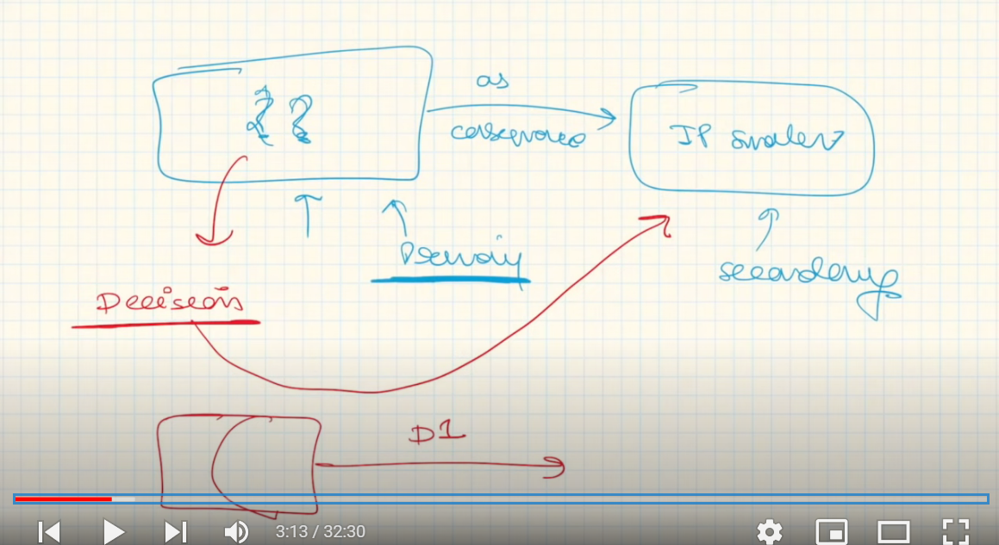

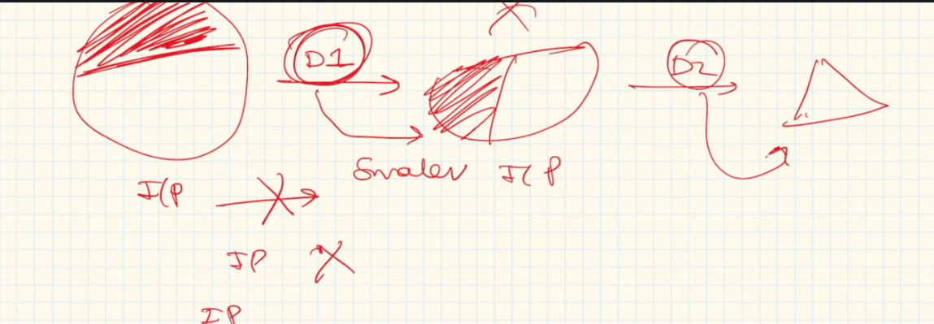

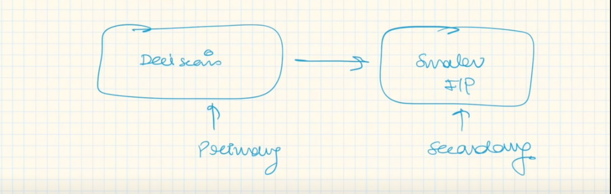

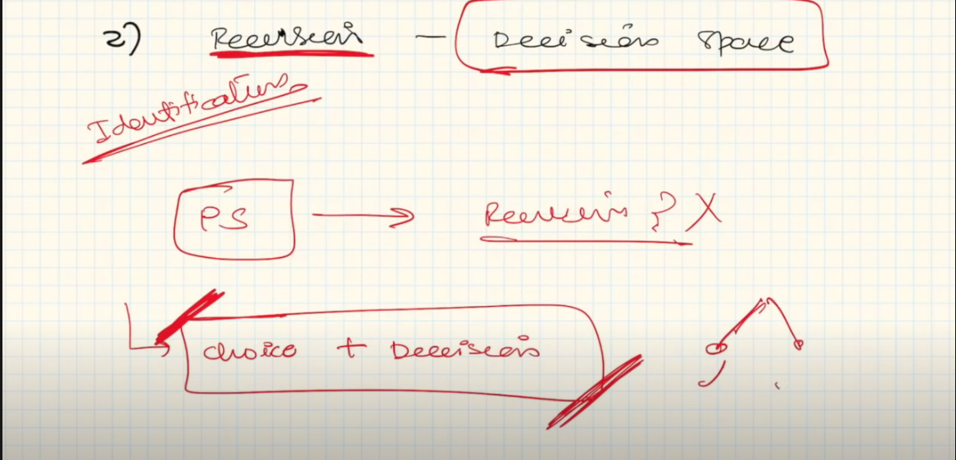

We make decision based on the choices we have in a problem.

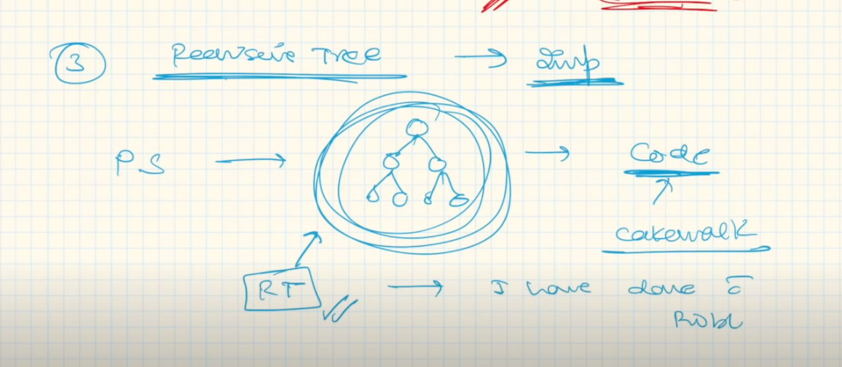

Let’s see a problem

Q. Given a string, find all possible subset of that string.

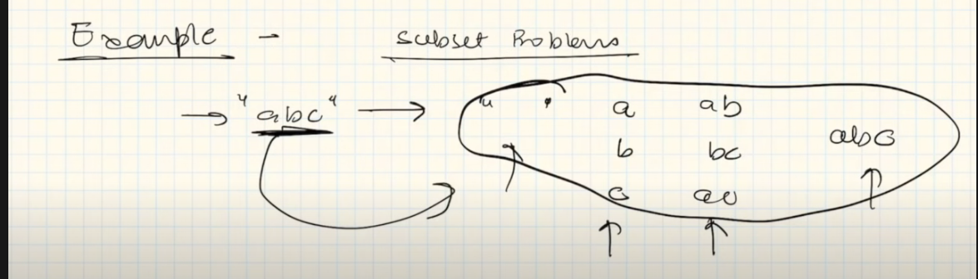

This denotes the choices that we have in this problem

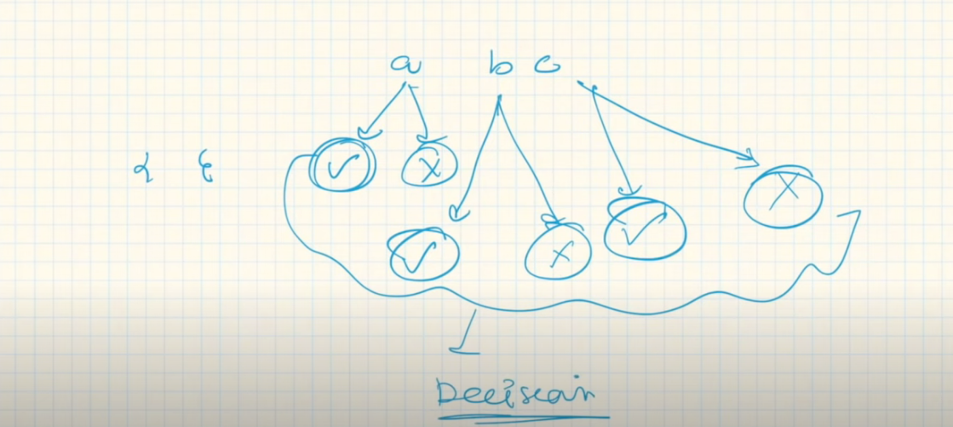

This denotes the decisions that we made.

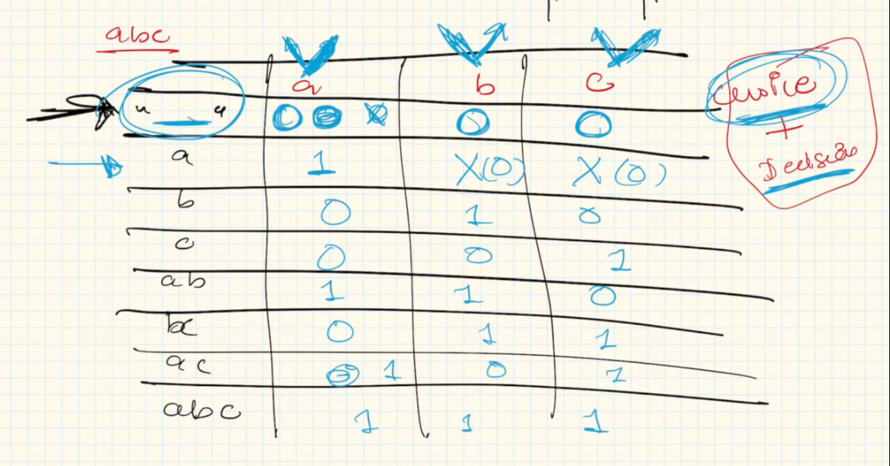

So we make decisions in recursion based on the choices that we have.

**Recursive Tree**

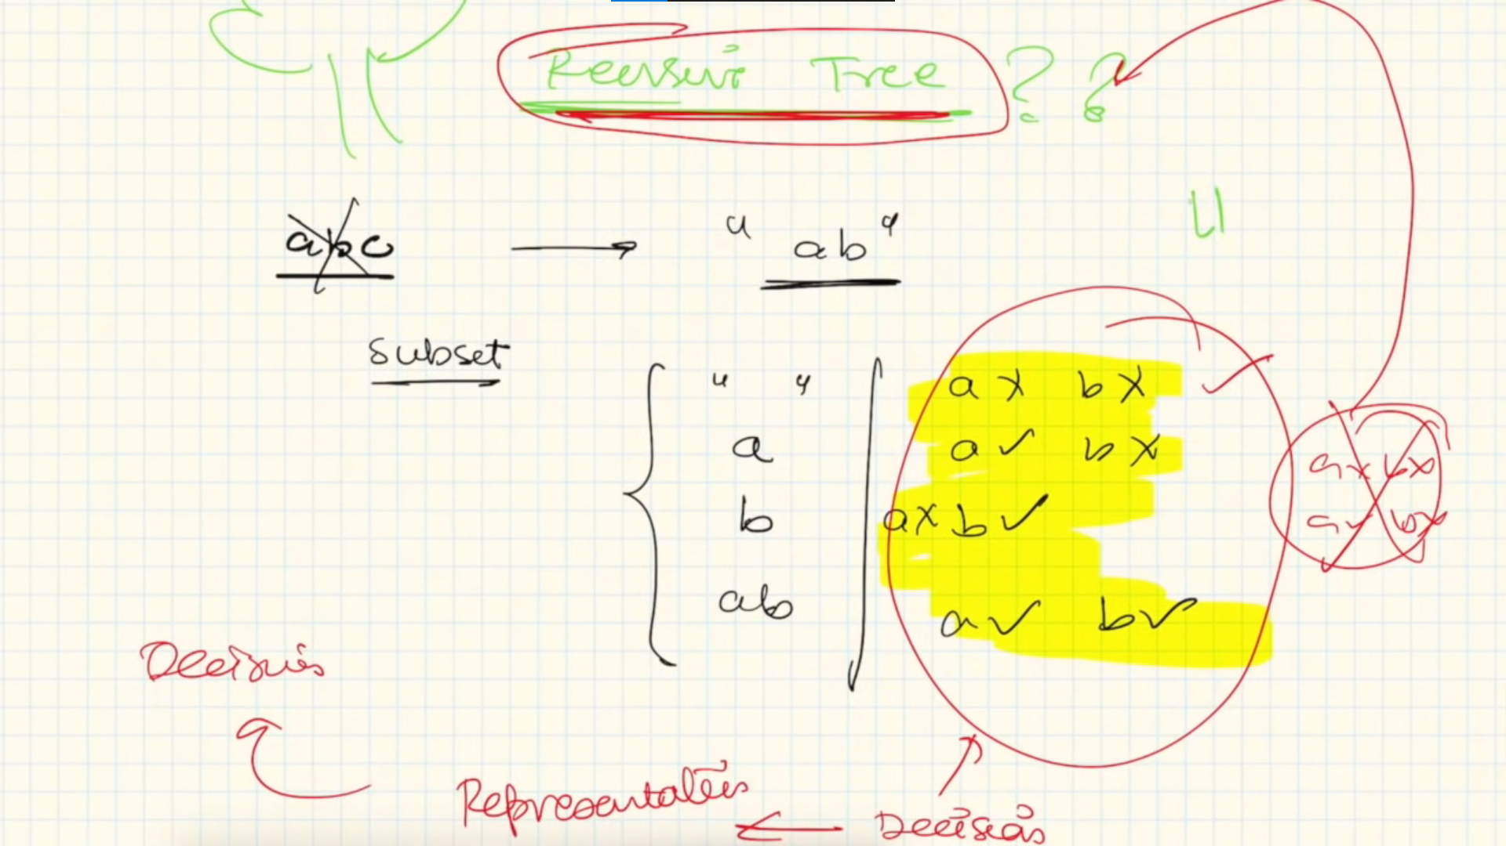

Recursive tree is used for representing the choices and decision that we make in recursion.

Way of drawing recursive tree

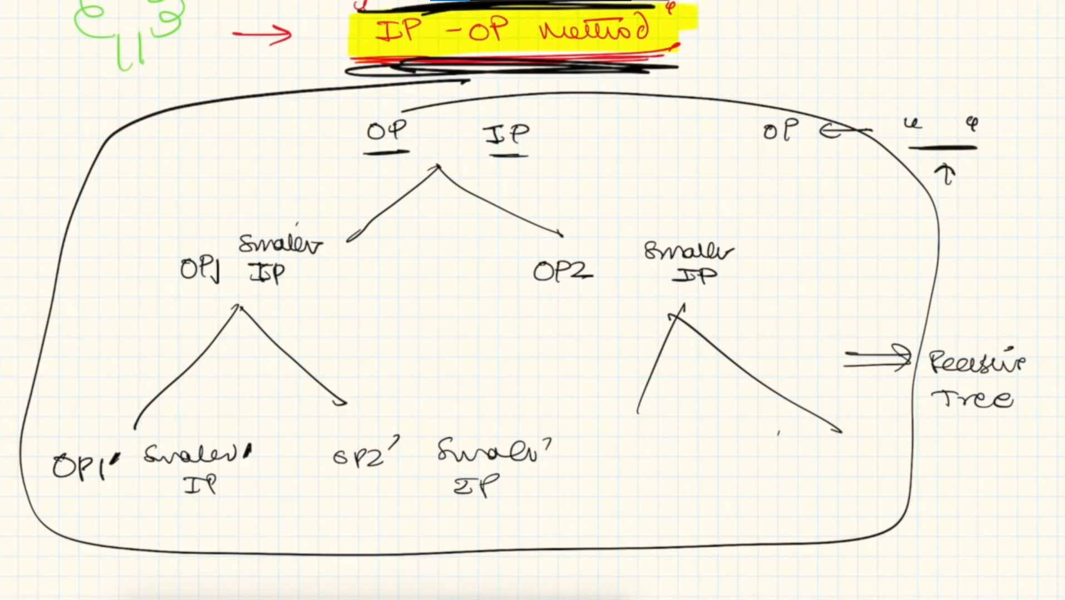

Let’s make recursive tree for this question

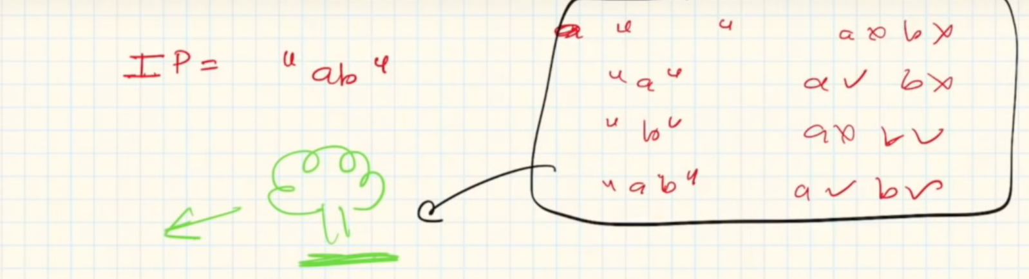

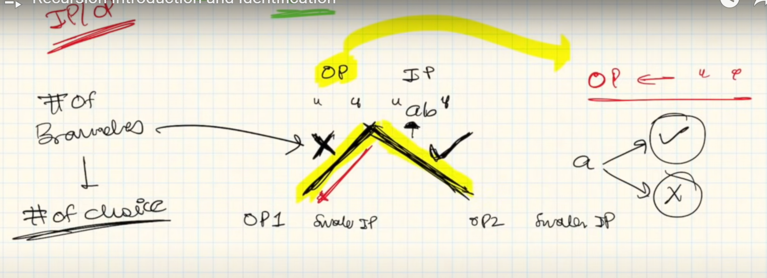

The number of branches in the tree denotes number of choices and if we move in any branch that denotes decision.

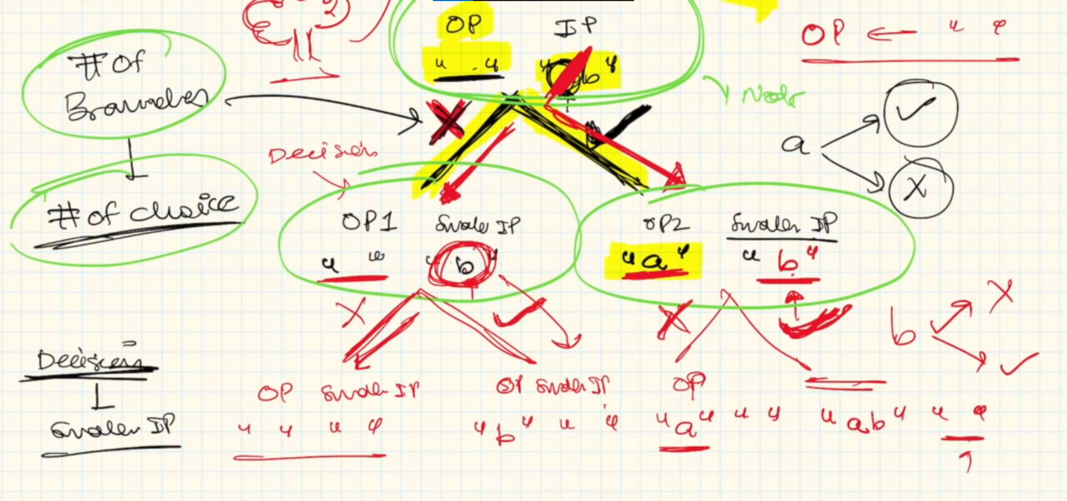

All leaf nodes denote our subsets.

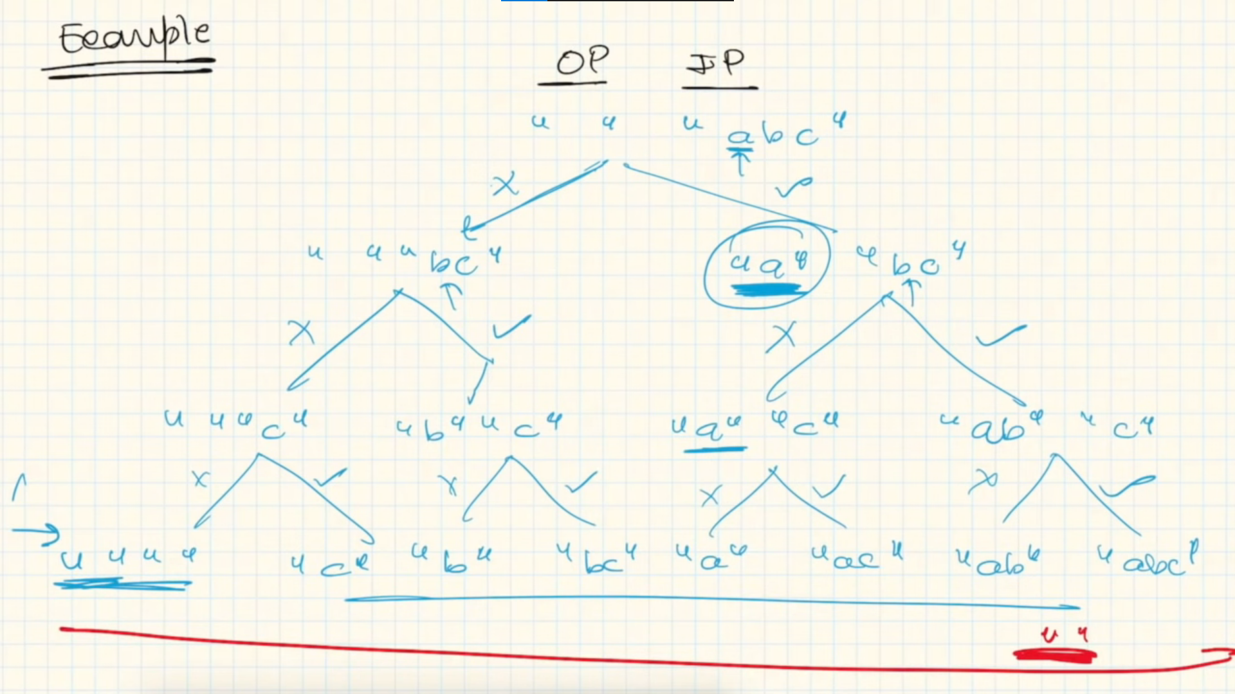

**Conclusion**

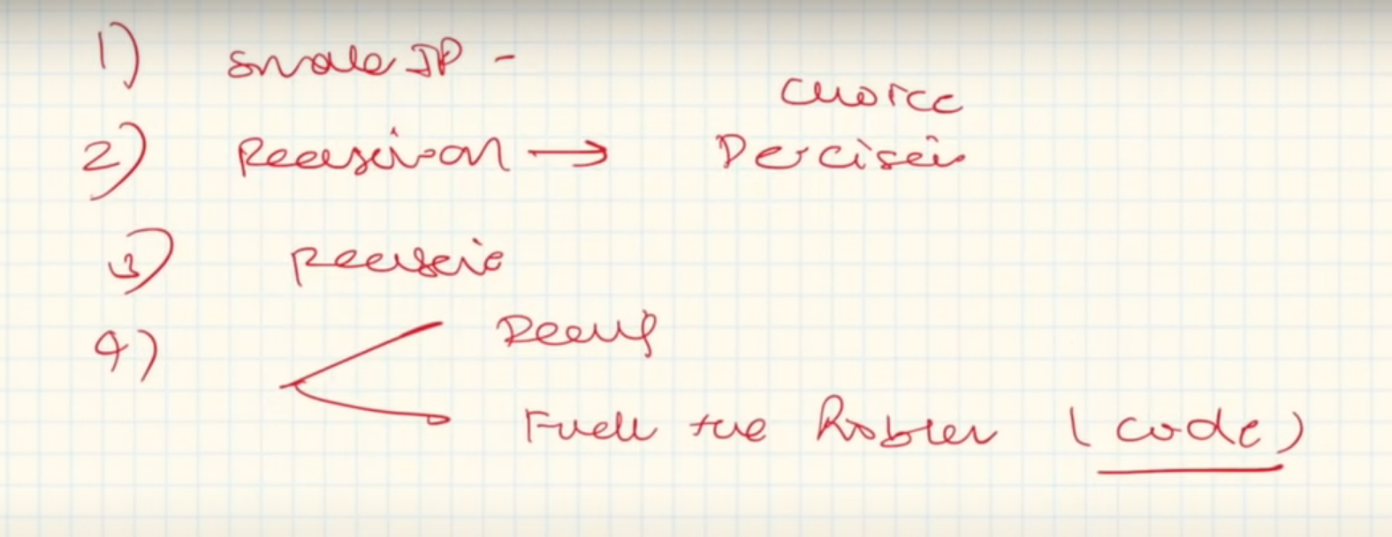

**Recursion is everywhere**

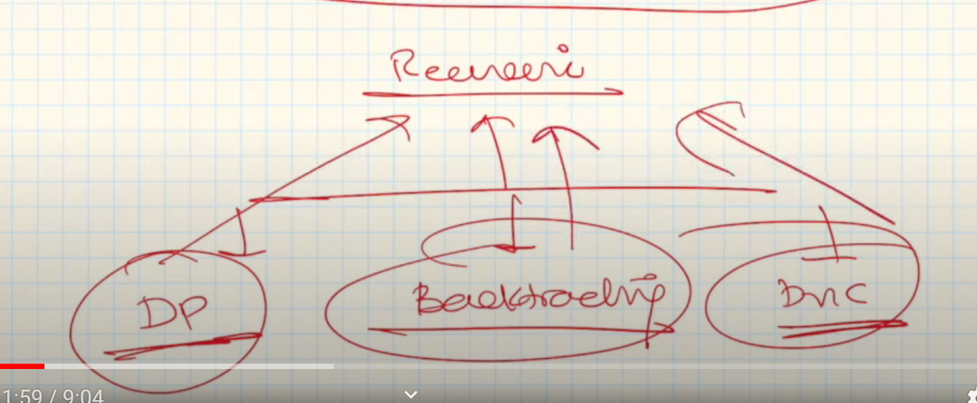

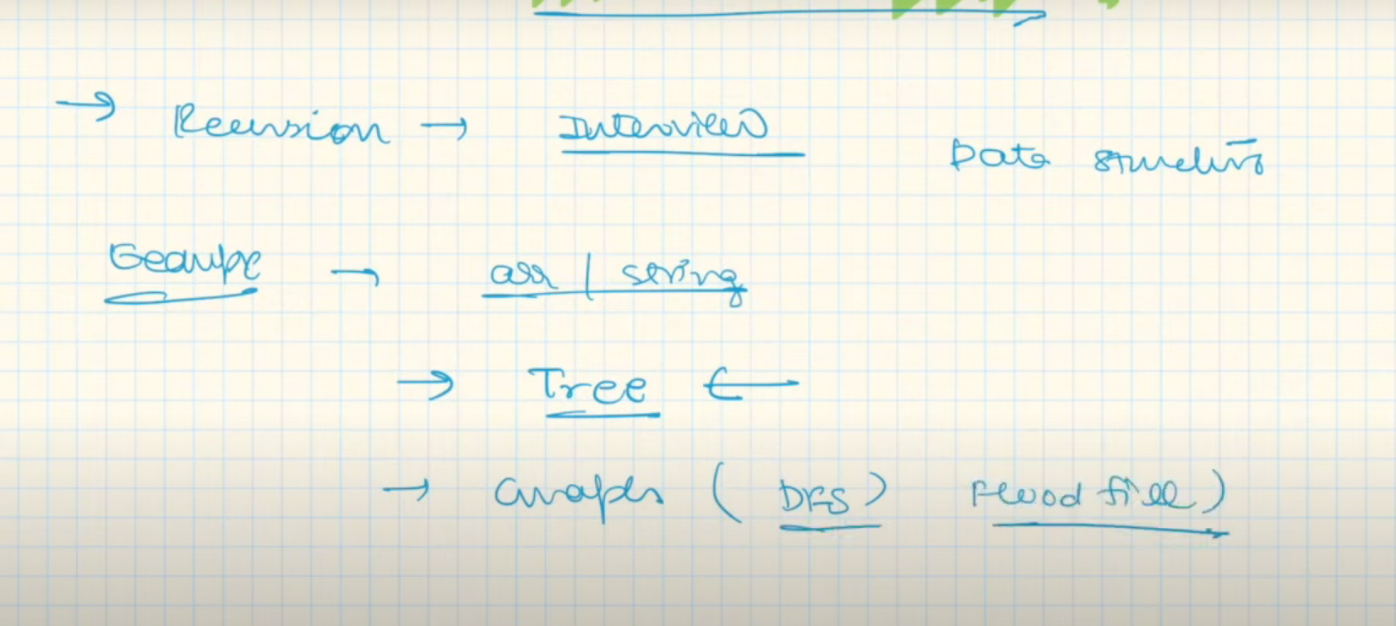

Recursion questions

